**Batch: B1**

**Roll No.: 16010122104**

**Experiment No. 07**

**Grade: AA / AB / BB / BC / CC / CD /DD**

**Signature of the Staff In-charge with date**

**TITLE: Demonstrate the Super Global Variables and File Uploading in PHP**

**AIM:** To understand various file operations and file upload in PHP



**Expected Outcome of Experiment:** Process external files in PHP.



# Books/ Journals/ Websites referred:

<https://www.javatpoint.com/php-file>

<https://www.geeksforgeeks.org/php-basics-file-handling/> 

**Procedure:**

File handling is needed for any application. For some tasks to be done file needs to be processed. File handling in PHP is similar as file handling is done by using any programming language like C. PHP has many functions to work with normal files. Those functions are:

**fopen()** – PHP fopen() function is used to open a file. First parameter of fopen() contains name of the file which is to be opened and second parameter tells about mode in which file needs to be opened, e.g.,

The PHP fopen() function is used to open a file.

# Syntax

resource fopen ( string $filename , string $mode [, bool $use_include_path = false [, resource $context ]] )

Example

<?php

$handle = fopen("c:\\folder\\file.txt", "r");

?>

# PHP Close File - fclose()

The PHP fclose() function is used to close an open file pointer.

Syntax

fclose ( resource $handle ) Example

<?php fclose($handle);

?>

# PHP Read File - fread()

The PHP fread() function is used to read the content of the file. It accepts two arguments: resource and file size.

Syntax

string fread ( resource $handle , int $length ) Example

<?php

$filename = "c:\\myfile.txt";

$handle = fopen($filename, "r");//open file in read mode

$contents = fread($handle, filesize($filename));//read file

echo $contents;//printing data of file fclose($handle);//close file

?>

Output

hello php file

# PHP Write File - fwrite()

The PHP fwrite() function is used to write content of the string into file.

Syntax

int fwrite ( resource $handle , string $string [, int $length ] ) Example

<?php

$fp = fopen('data.txt', 'w');//open file in write mode fwrite($fp, 'hello ');

fwrite($fp, 'php file'); fclose($fp);

echo "File written successfully";

?>

Output

File written successfully

# PHP Delete File - unlink()

The PHP unlink() function is used to delete file.

Syntax

bool unlink ( string $filename [, resource $context ] ) Example

<?php unlink('data.txt');

echo "File deleted successfully";

?>

# Problem Statement:

Uploading .jpg, .jpeg, .png files.

# Description of the application implemented with output:

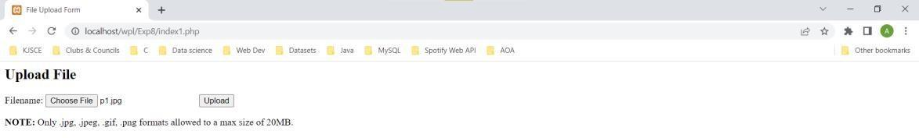

Upload successful,

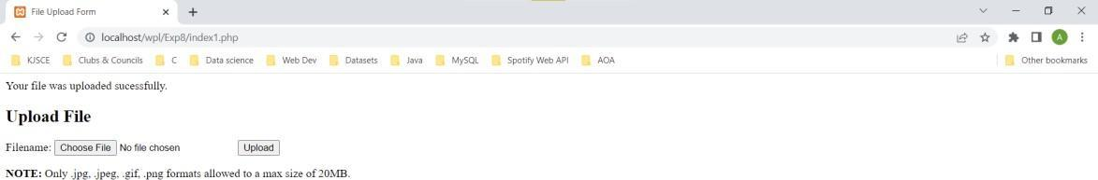

When the file already exists,

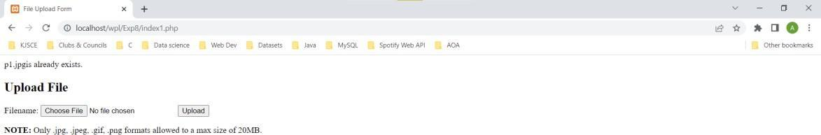

**Post Lab Questions:**

# 1. Perform following file operations with respect to problem statement/application:

Open, read and write with various modes, append, delete and downloading file.

**Answer: Code with output screenshots Open and Read**

<!DOCTYPE html>

<html>

<body>

<?php

$myfile = fopen("myFile.txt", "r") or die("Unable to open file!"); echo fread($myfile, "50");

fclose($myfile);

?>

</body>

</html>



**Write**

<!DOCTYPE html>

<html>

<body>

<?php

$fp = fopen("myFile.txt", "w");//open file in write mode fwrite($fp, "Name: ");

fwrite($fp, "Hussain Pettiwala"); fclose($fp);

echo "File written successfully";

?>

</body>

</html>

